Lab Exercise 3: DNS & Socket Programming

zid: z5228006 name: MINGLANG XIE

**Exercise 3: Digging into DNS:**

Question 1:

The IP address of [www.eecs.berkeley.edu](http://www.eecs.berkeley.edu) is 23.185.0.1. To get this answer we sent a type A query.

Question 2:

The CNAME is live-eecs.pantheonsite.io (canonical name is usually long and hard to remember). An alias for this server is a mnemonic that easy to remember, and it is useful when running multiple services from a single IP address.

Question 3:

ns-233.awsdns-29.com, ns-644.awsdns-16.net, ns-2013.awsdns-59.co.uk, ns-1213.awsdns-23.org are the authoritative name serves for eecs.berkeley.edu.

The addition section contains IP address for these four authoritative name servers. The AAAA records are for IPv6 address

Question 4:

The IP address of the local nameserver for my machine is included at the end of the output, 129.94.242.2#53. This is the local DNS server for the CSE network. It is made by connecting the CSE login servers via SSH.

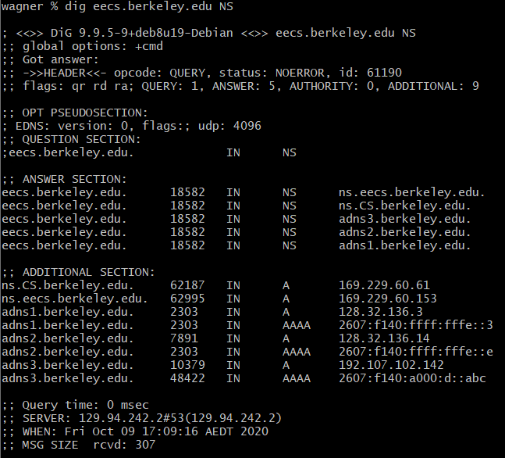Question 5:

The nameservers for the “eecs.berkeley.edu” domain are ns.eecs/ns.CS/adns3/adns2/adns1.berkeley.edu, and their IP address are:

169.229.60.153, 169.229.60.61, 2607:f140:a000:d::abc, 2607:f140:ffff:fffe::e, 2607:f140:ffff:fffe::3. (Note that AAAA records are for the IPv6 address)

Question 6:

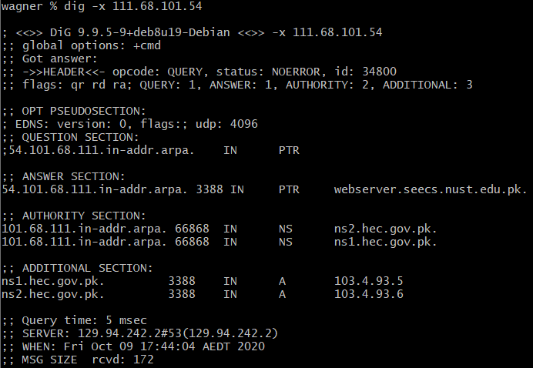We use reverse DNS for this:

The hostname corresponding to 111.68.101.54 is webserver.seecs.nust.edu.pk.

Question 7:

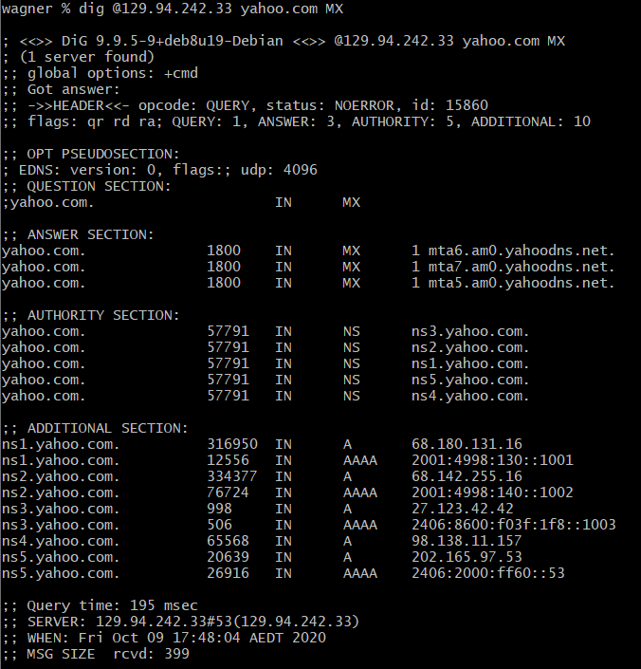We did not get an authoritative answer from the server we queried (orchestra.cse.unsw.edu.au) since the flags do not contain aa. This is because it only has authority for the cse.unsw.edu.au domain, but not for the Yahoo domain.

Question 8:

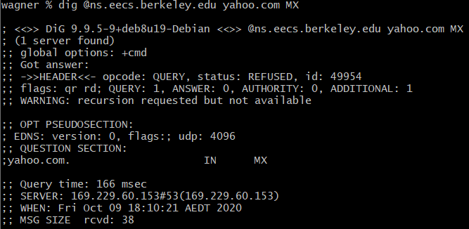when we try the berkeley nameservers we do not get a response. The status of the reply is REFUSED. The reason could be that these name servers do not reply to DNS queries that are sent from devices which are not part of the Berkeley network, for security measure.

Question 9:

We query one of the authoritative nameservers for the domain yahoo.com:

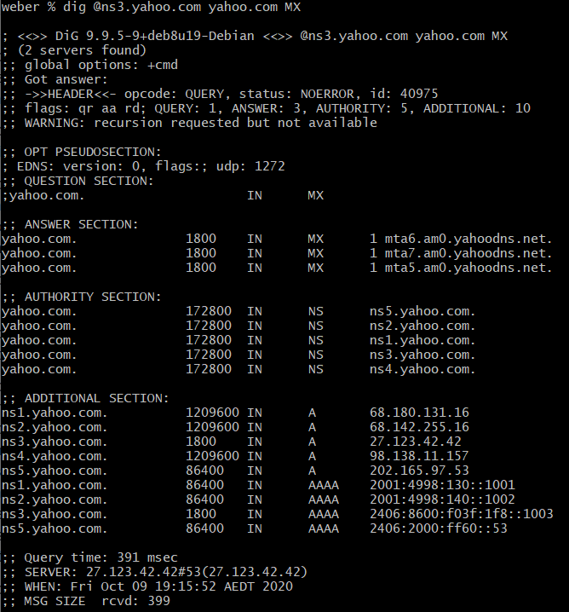

Question 10:

Assume the current hostname is lyre00.cse.unsw.edu.au. First query for the IP address of the root domain.

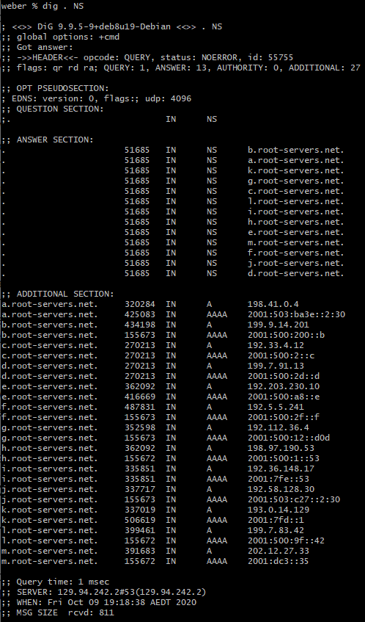

Next query one of the root nameservers:

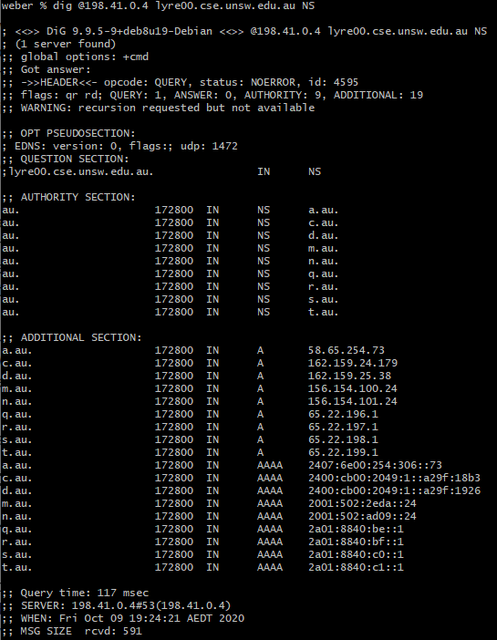

Next query to one of the au. nameservers:

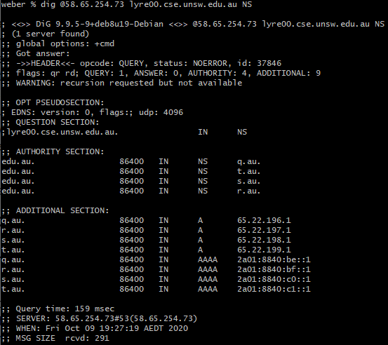

Next query to one of the edu.au. nameservers:

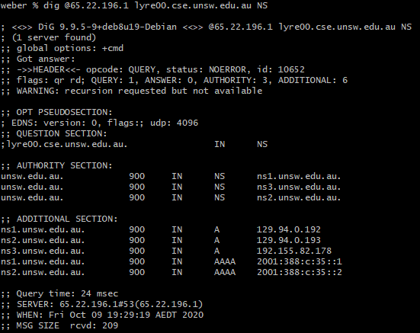

Next query to one of the unsw.edu.au. nameservers:

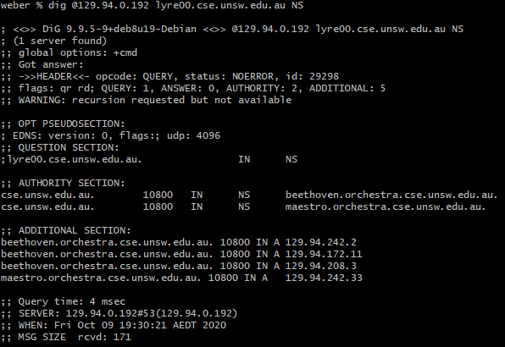

Next query to one of the cse.unsw.edu.au. nameservers (However, we use type A for this query):

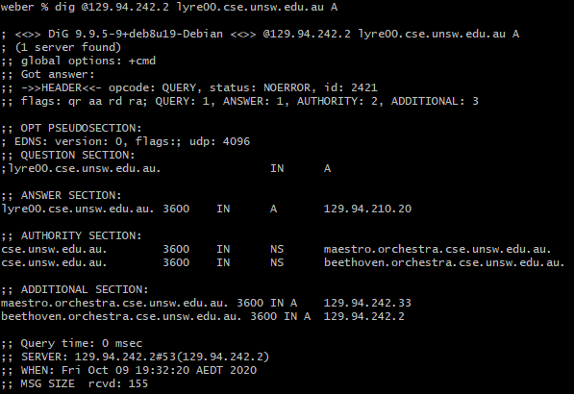

The IP address for lyre00.cse.unsw.edu.au is 129.94.210.20. Starting from the root name server, 5 DNS servers need to be queried.

Question 11:

Yes, a physical machine can have several names and/or IP addresses, and a IP address may have been associated with several hostname.